Open Source Software Lab Assignment 3

Answer 1-

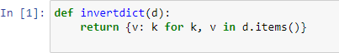

Answer 2-



Answer 3-

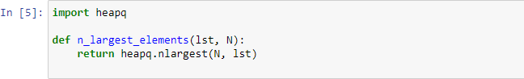

Answer 4-

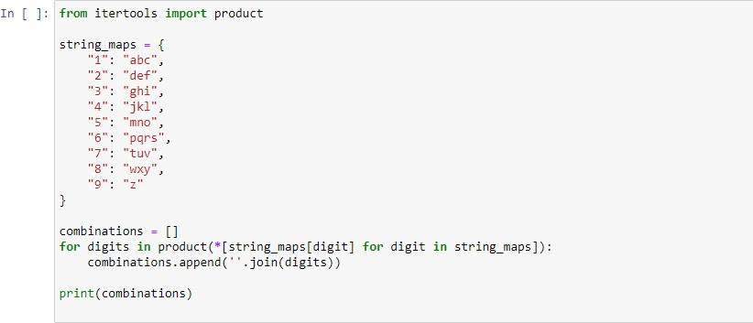

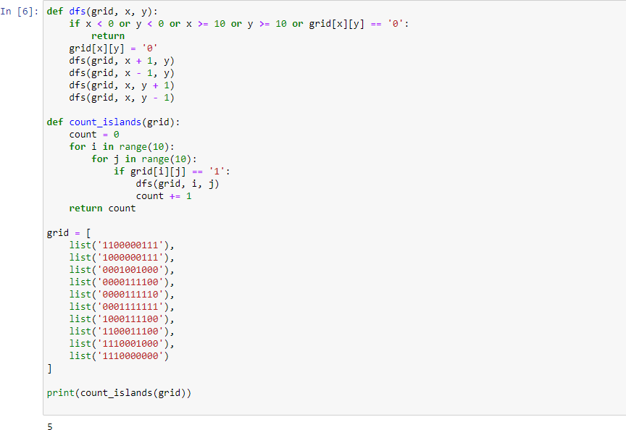

Answer 6-

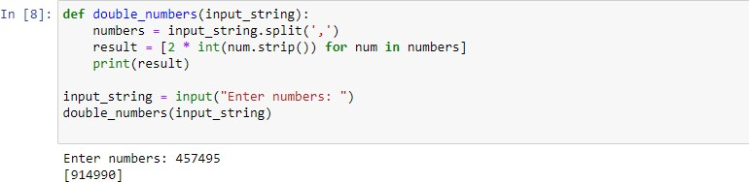

Answer 7-

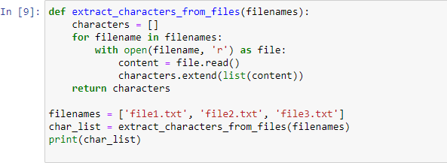

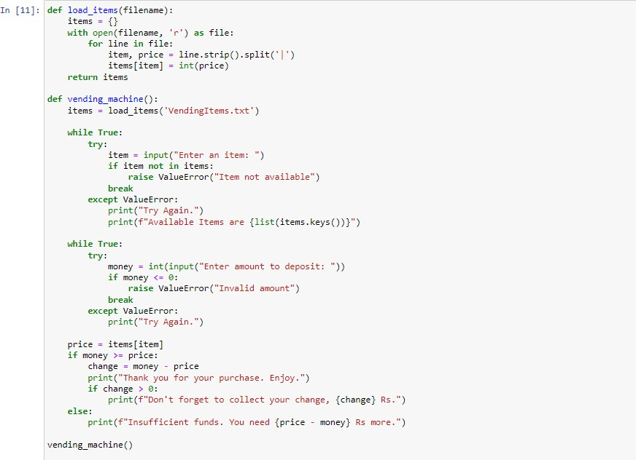

Answer 9-

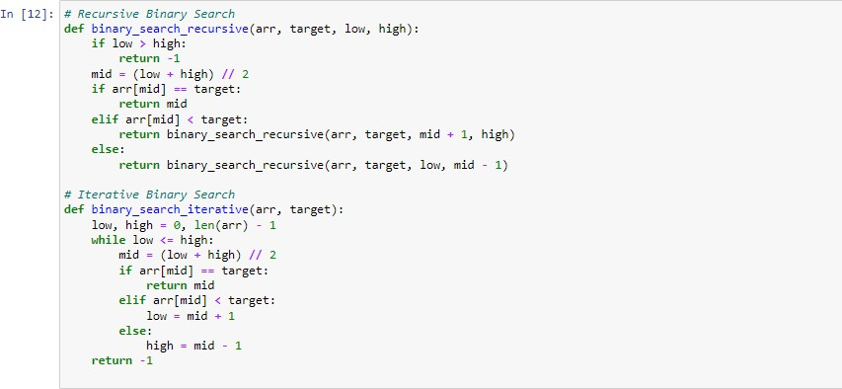

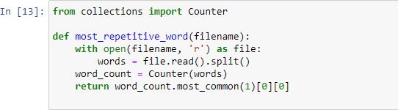

Answer 11-

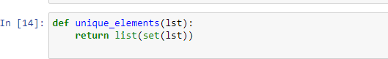

Answer 12-

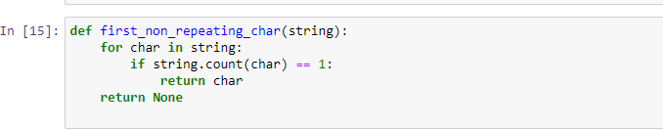

Answer 13-

